Assignment 1 – Benchmark App

SD6503 - Testing & Secure Coding

chunguang liu 2230873

YEAR

# Automation Testing

This automation testing report includes screenshots of all the codes and the final results.

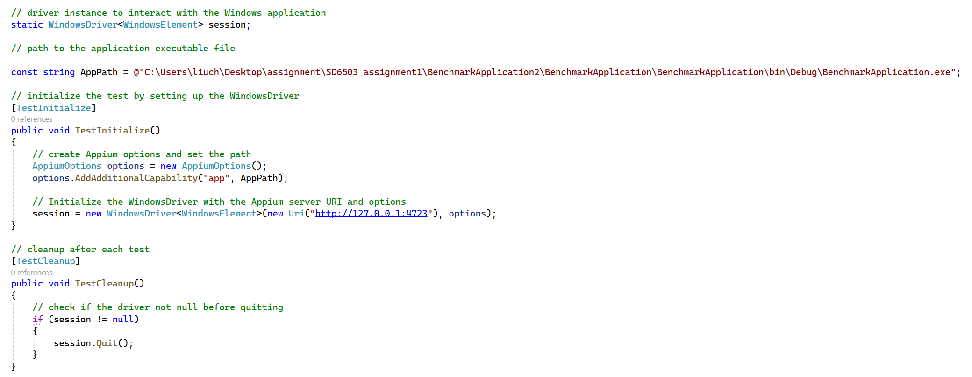

Figure 1: Automation Testing Setup

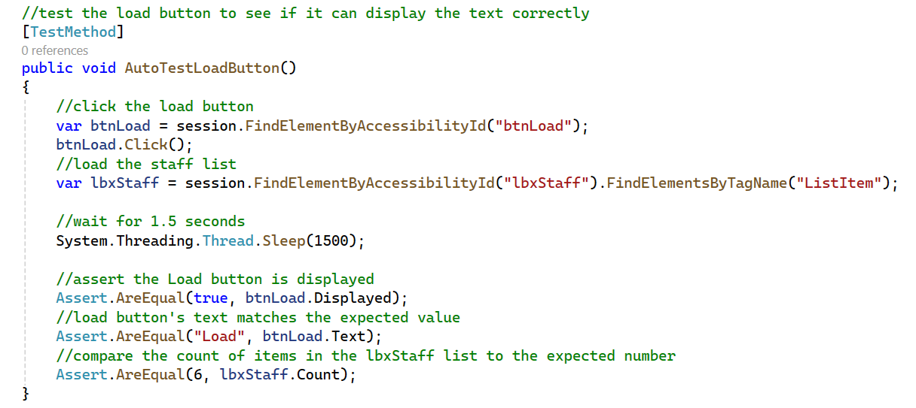

Figure 2: AutoTestLoadButton

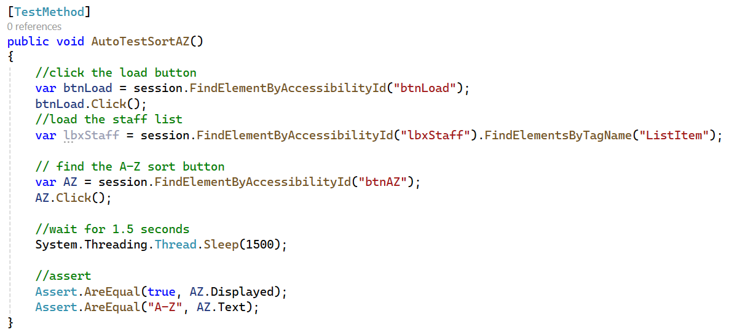

Figure 3: AutoTestSortAZButton

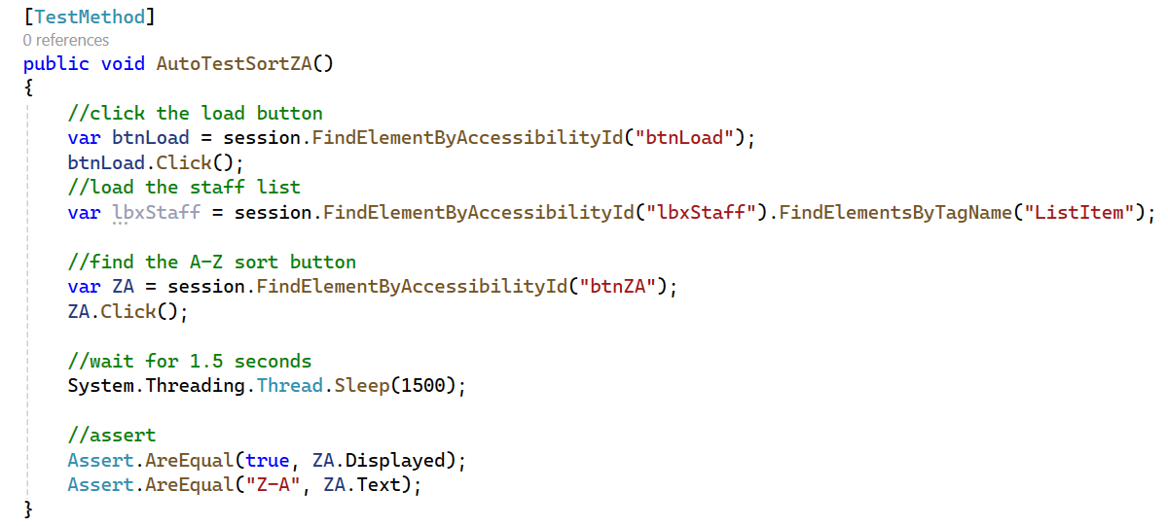

Figure 4: AutoTestSortZAButton

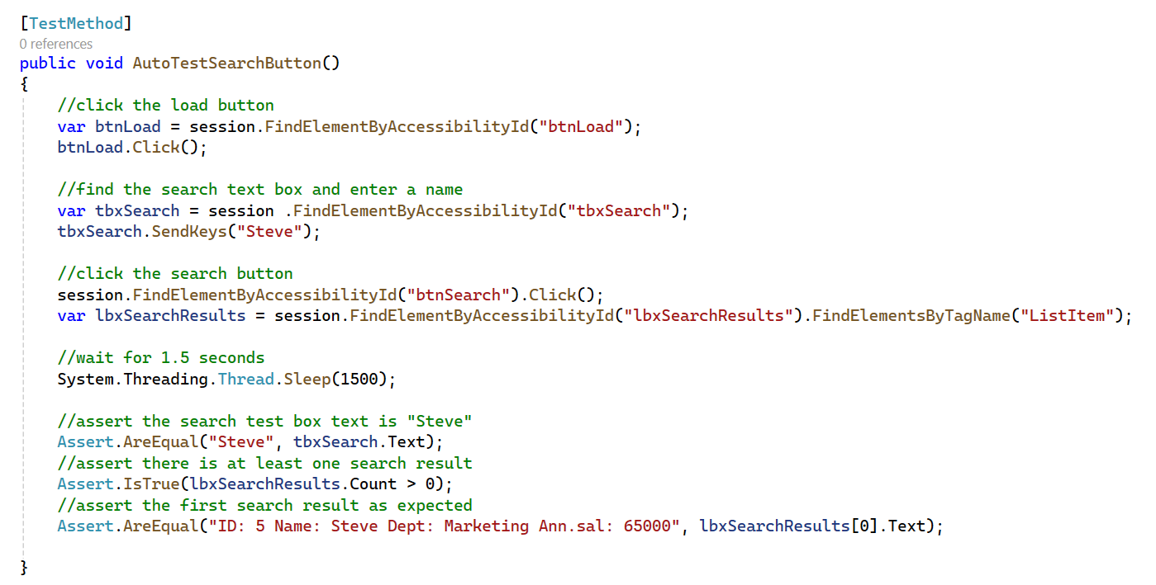

Figure 5: AutoTestSearchButton

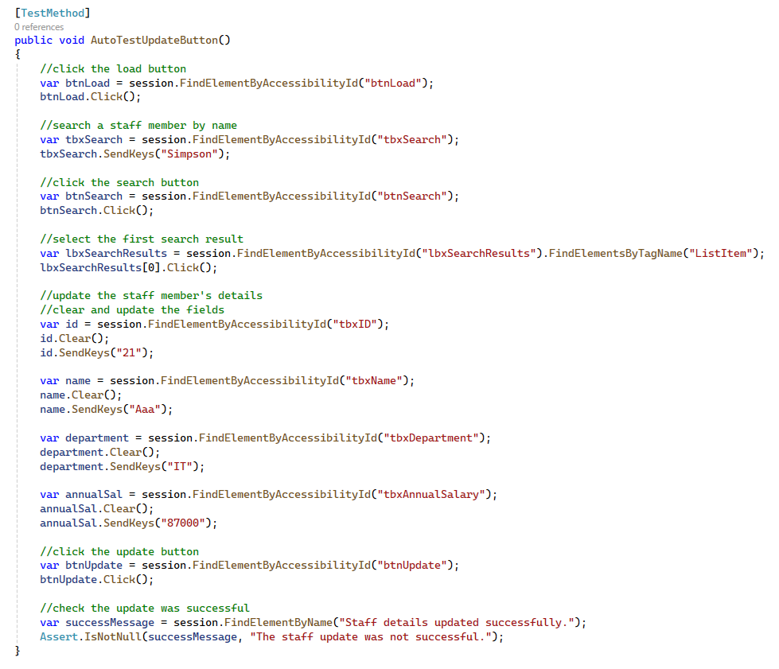

Figure 6: AutoTestUpdateButton

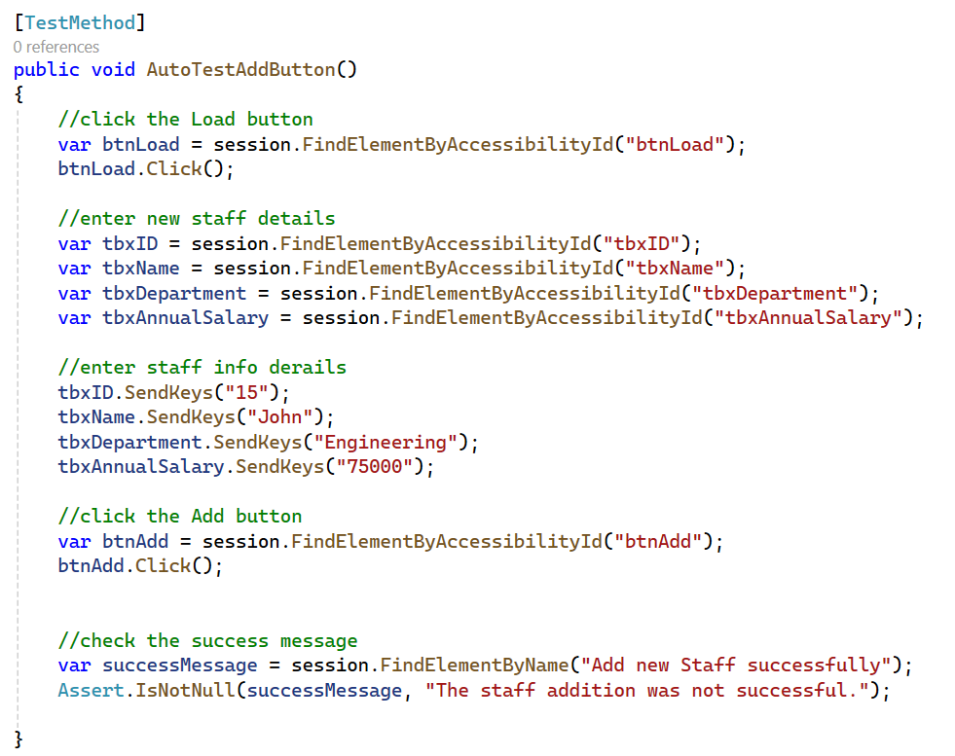

Figure 7: AutoTestAddButton

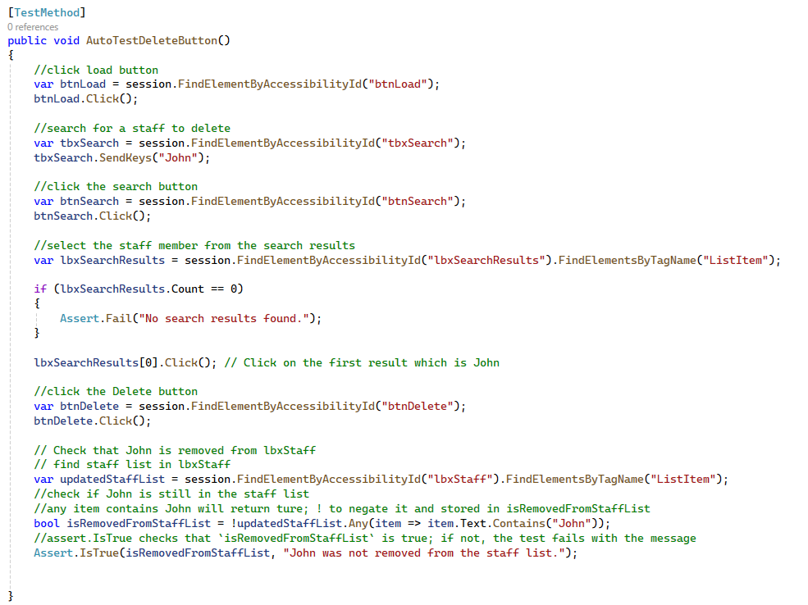

Figure 8: AutoTestDeleteButton

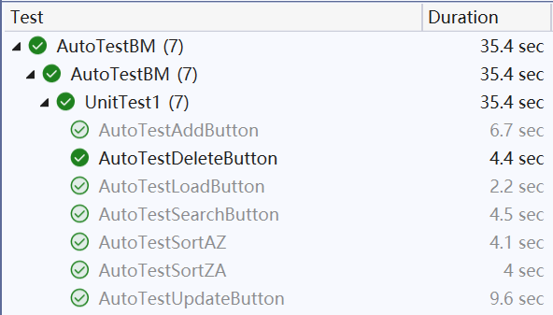

Figure 9: AutoTestResults